
L.J. Institute of Computer
Application
L.J. University

Master of Computer Application - Cybersecurity Specialization

MCA Cyber Security

3rd Semester

Subject Name: Cybersecurity Fundamentals & Network Security

Subject Code: MCACS301

Submitted To: Ms. Gagana Narsipalli

Submitted By: Chudasama Vishal
Roll Number: E02

CERTIFICATE

This is to certify that Mr. Chudasama Vishal Bhimashibhai with enrollment number 25004401110069 Semester 3rd has successfully completed his/her laboratory experiments in the Cybersecurity Fundamentals & Network Security (MCACS301) from the department of MCA Cyber Security during the academic year 2025 - 2028

Date of Submission:

Staff in charge: Ms. Gagana Narsipalli

TABLE OF CONTENT
Sr. No | Experiment Title | Page No | Date of Completion | Marks (Out of 10) | Sign
1 | Wireshark: HTTP Traffic Analysis | 4

Practical-1

AIM: “To capture the live network traffic using Wireshark and apply a display filter to identify HTTP credentials.”

Wireshark is a network protocol analyser used to capture and examine network traffic in real time. It collects packets transmitted through a selected network interface and displays their protocols, source and destination information, and other details.
Wireshark also provides display filters to analyses specific types of traffic. In this practical, HTTP traffic will be captured and analysed to identify credentials transmitted through an HTTP request.

Procedure
Step 1: Select Network Interface
Open Wireshark and identify the network interface currently connected to the Internet, such as Wi-Fi or Ethernet.
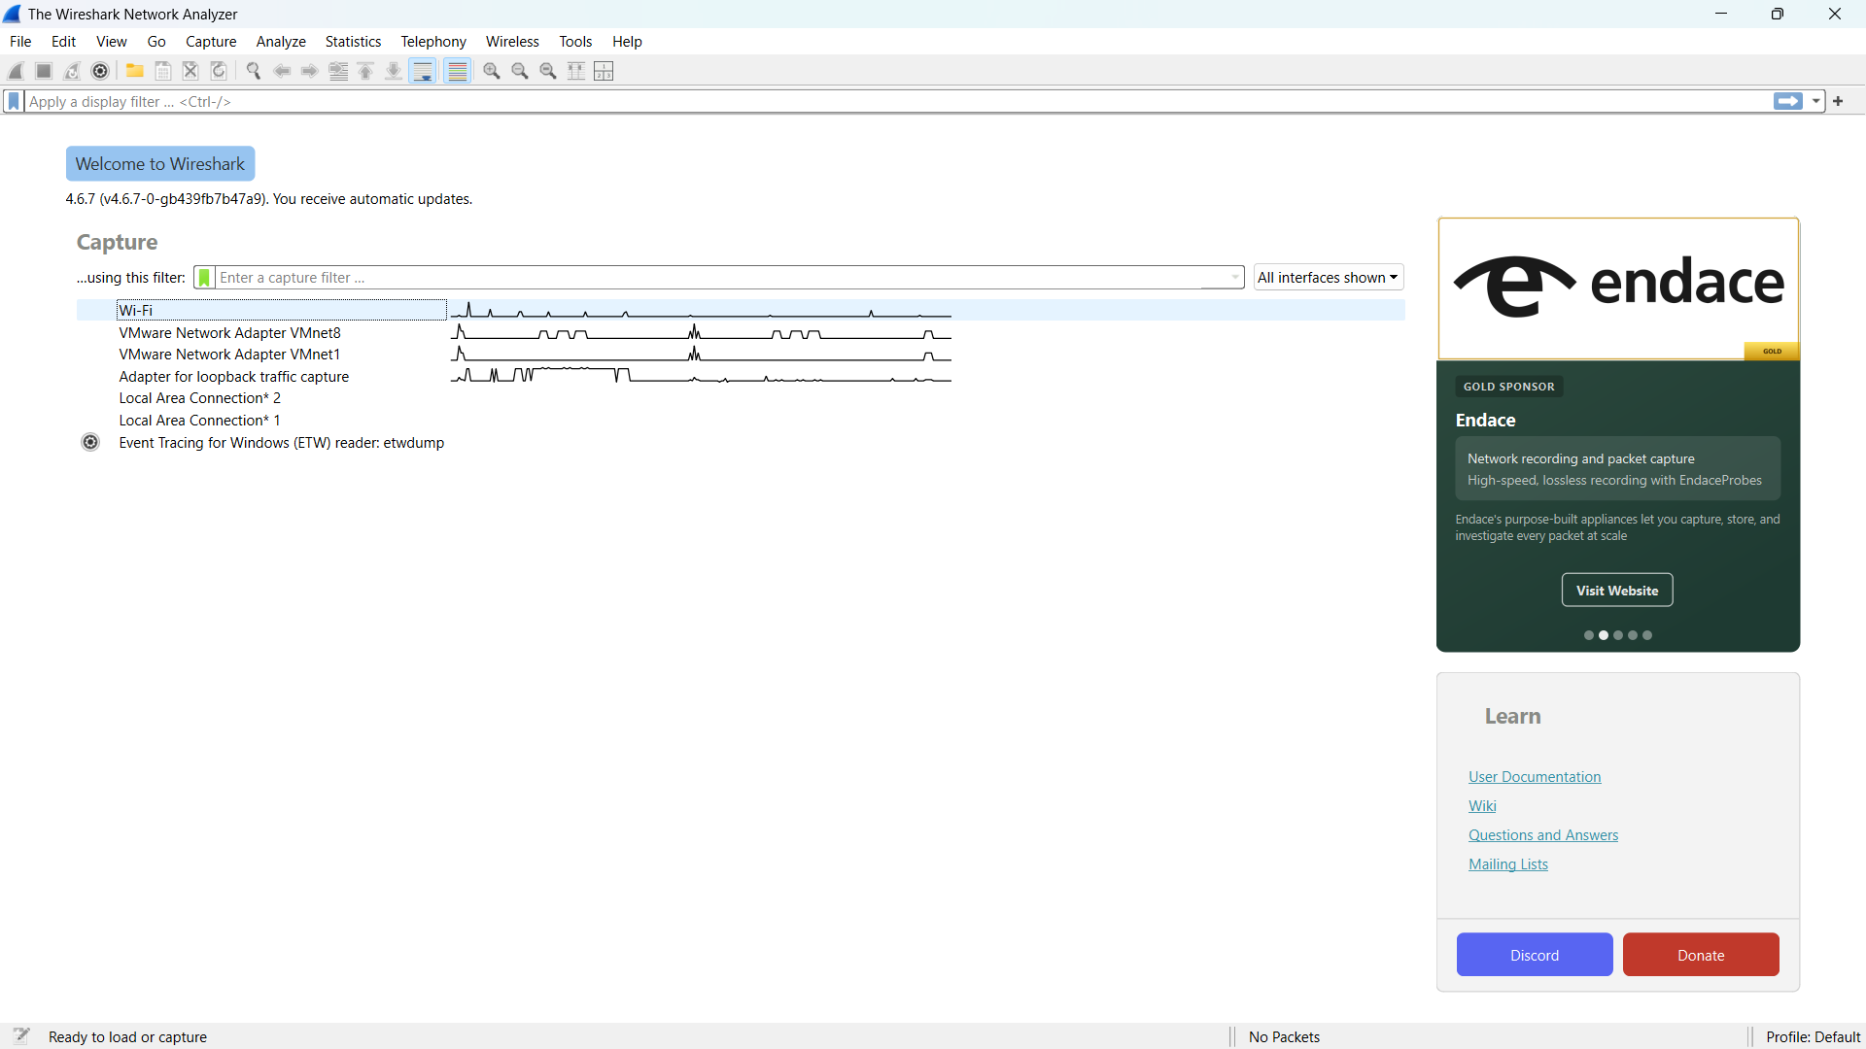
Screenshot 1: Wireshark main screen showing the available network interfaces.
Explanation: The active network interface is highlighted with a box. It is selected to capture the live network traffic.
Highlight: Box the active interface showing live traffic.
Action: Double-click the active interface to start packet capture.

Step 2: Start Packet Capture
Double-click the active network interface to begin capturing live packets.
Wait for a few seconds so that packets start appearing in the packet list.
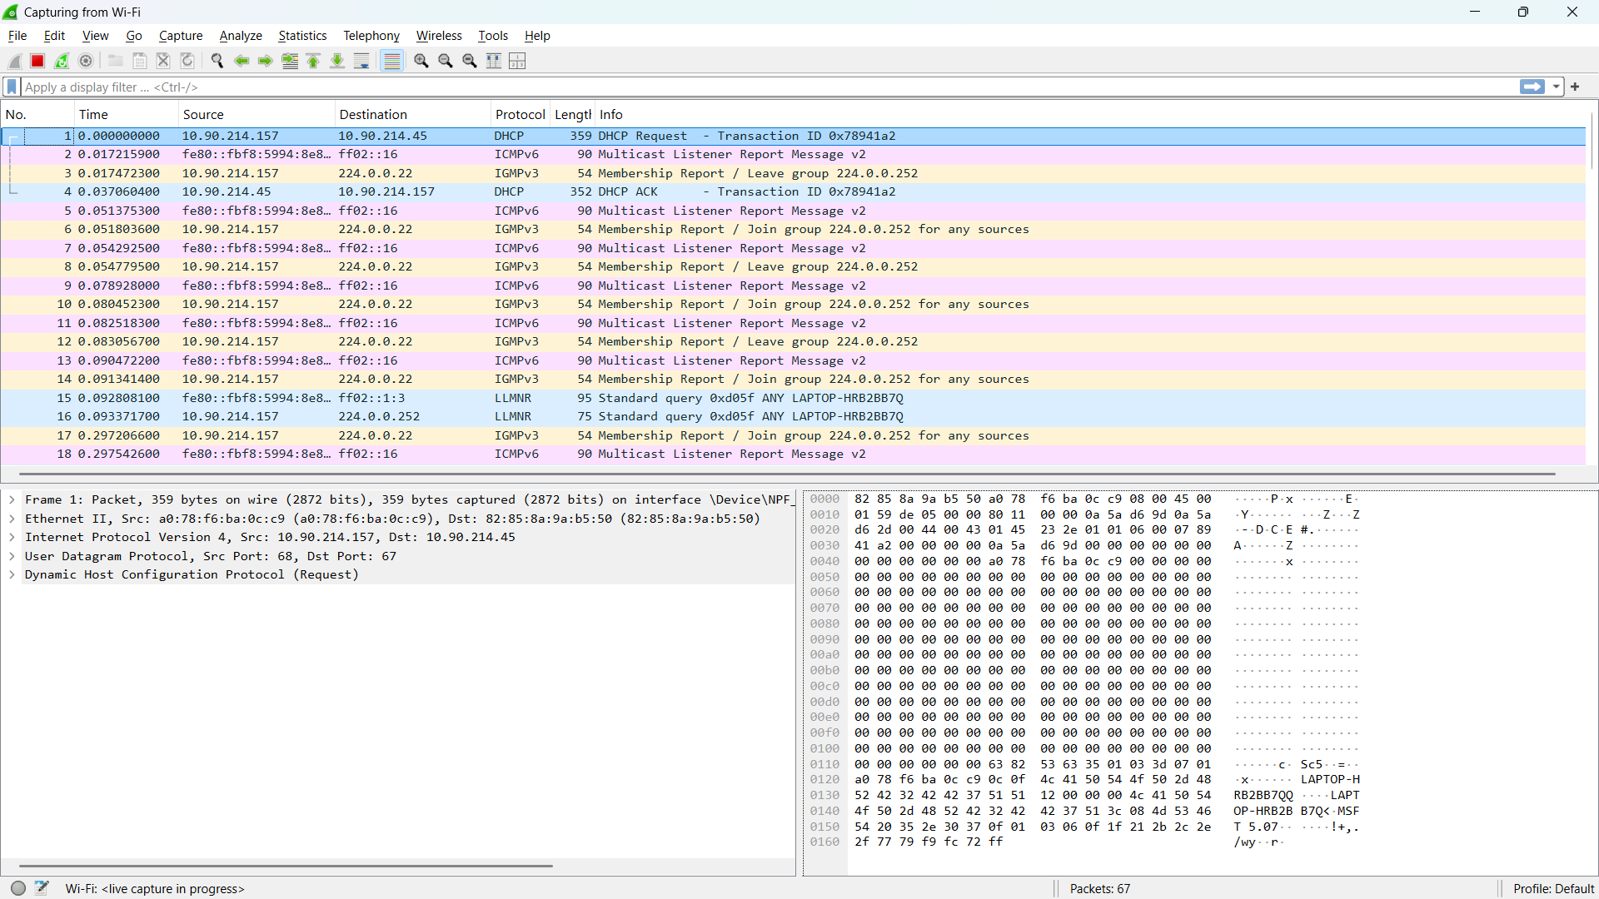
Screenshot 2: Wireshark packet capture window showing live packets.
Explanation: The captured packets are displayed in real time, showing information such as packet number, time, source, destination, protocol, and packet length.
Highlight: Box the Protocol column and a few visible packets.
Action: Keep the capture running for the next step.

Step 3: Visit HTTP Site
To generate HTTP traffic for analysis, open a browser and visit the following HTTP-based demo login page: http://demo.testfire.net/login.jsp
Enter dummy credentials in the login form and click Login while Wireshark is capturing packets.

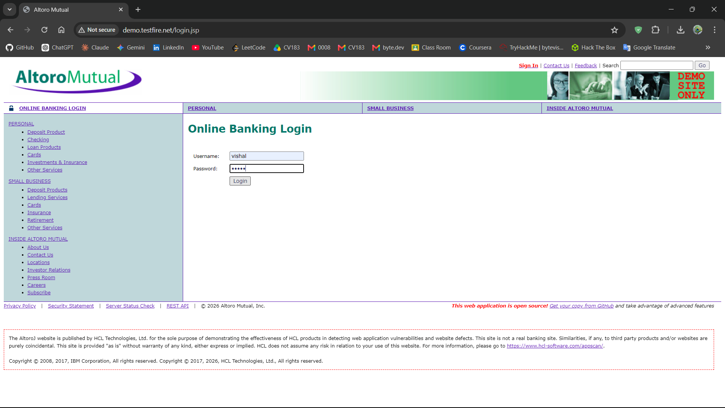
Screenshot 3: HTTP demo login page showing the login form.
Explanation: The HTTP-based demo login page is used to generate a login request containing test credentials for analysis in Wireshark.
Highlight: Box the HTTP URL and the username/password fields.
Action: Enter dummy credentials and click Login. Keep Wireshark capture running.

Step 4: Apply HTTP Display Filter
In Wireshark, stop capturing packets by clicking red colour square icon on top and then click the Display Filter bar at the top and enter:
http
Press Enter.
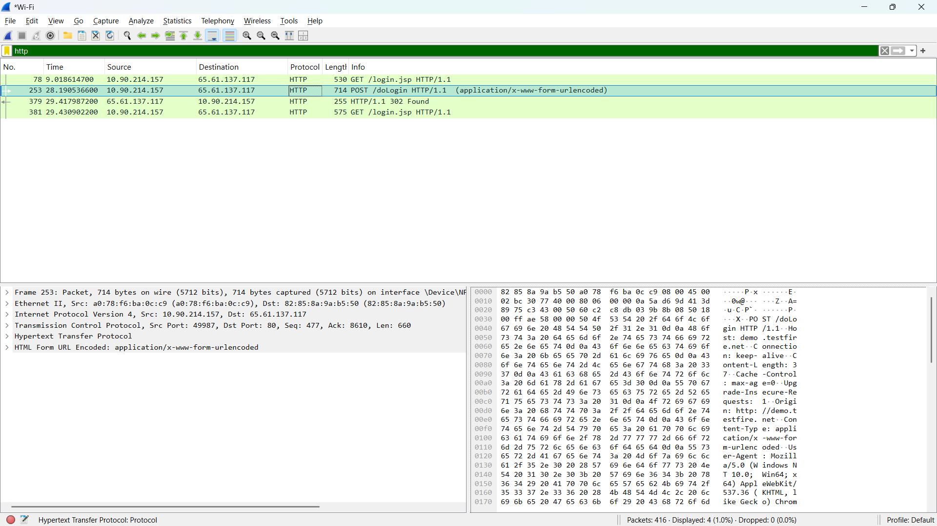
Screenshot 4: Wireshark showing the filtered HTTP packets.
Explanation: The http display filter limits the packet list to HTTP traffic, making it easier to locate the login request generated from the demo website.
Highlight: Box the http filter in the filter bar and the HTTP packets in the Protocol column.
POST /doLogin HTTP/1.1
Action: Locate the HTTP packet corresponding to the login request.

Step 5: Identify HTTP Credentials
Select the HTTP packet corresponding to the login request. (select POST /doLogin HTTP/1.1) In the Packet Details pane, expand the Hypertext Transfer Protocol & HTML Form URL Encoded section.
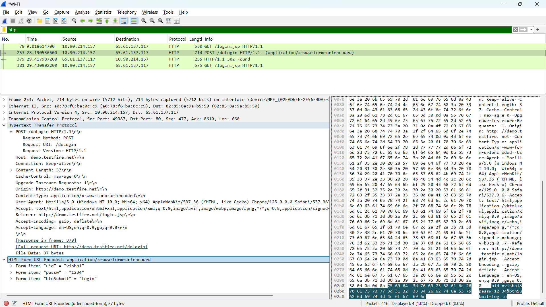
Screenshot 5: Wireshark showing the HTTP login request and submitted test credentials.
Explanation:
The selected HTTP POST request contains the login form data. The HTML Form URL Encoded section shows the submitted username and password, demonstrating that credentials sent over unencrypted HTTP can be viewed in captured network traffic.
Highlight:
- Box POST /doLogin HTTP/1.1 in the packet details.
- Box the HTML Form URL Encoded section.
- Box the uid = vishal and passw = 1234 values.
Action:
Verify that the dummy username and password entered on the HTTP login page are visible in the captured HTTP request.

Conclusion:
Wireshark was successfully used to capture live network traffic and filter HTTP packets using the http display filter. The HTTP POST request was analyzed, and the submitted dummy credentials were visible in the captured packet, demonstrating that credentials transmitted over unencrypted HTTP can be exposed during network traffic analysis.

Practical-2

AIM:

Conclusion:

